# 1: a garfing introduction

‘Wake up, Garfield from Garfield Kart – Furious Racing.’, said the clumsy, mediocre looking male living organism with a mildly large head.  
‘It’s time to wake up despite you literally being a feline who does not have any responsibilities in life.’  
The funny orange above-average-width feline peeked from his blanket, his eyes only 0.69% opened, as he saw the shoes of his clumsy owner a meter away from him. What goofy individual would wear shoes in the house, what a silly lad! The lasagna-admiring cat did not question this matter, however. He knew that his owner would always wear two different types of socks anyway. Slowly, Garfeidl would close his eyes again, knowing that the chances of it being the first day of the week were quite high.

‘I am not a big fan of the Monday.’, he said to himself. He prepared himself to go back into a state of being unawake, as he had been unasleep for more than 6 seconds, causing him to grow rather drowsy. However, the hit person Jon Arbuckle from The Garfield Show had other ideas. As soon as he witnessed the fat feline going back to sleep, he had to take action immediately. He heroically reached for his pocket, pulling out his Nokia 3310 Classic 113g 22m portable mobile phone device. On the screen he loaded an image of a mischievous, identical looking gray feline (even though the screen of his phone was green like a Gameboy, Jon simply didn’t care), which looked very much like Garf Field himself. However, this was no ordinary feline, as the mere presence of the image material being in a 10km radius of the orange Felis Catus, triggered an intensive neuron activation inside of his brain. Filled with adrenaline, garfeidlssdlf eyes widened, and he jumped into the air, latching towards the portable device that Jonathan Arbuckle was holding into his hand, as if he was identical to the version of himself that was present in the hit videogame ‘Nickelodeon All Star Brawl 2’. Despite this occurrence, Jon quickly managed to avoid Grefiled’s jump, having predicted this event from long ago.  
‘Nuh-uh’, said the now elegant looking male human being towards his pet, proud of his achievement of successfully baiting the attack. Quickly he got rid of the imagery on his phone, the presence of the gray Catus Domesticus no longer being a necessity. Gafrield was now fuming, not very pleased with the action that his owner took.  
 ‘Jonathan Garfbuckle II, I require Italian consumables in order to compromise for the devious activity that you just performed on me.’, garfiefl said.  
Jon, however, brought forward a plate with a single leaf of lettuce, as he said: ‘No garmfield, you know what day it is. It is the very first day of the week, meaning it is time for your diet. And since we both originate from a comic strip released in 1978, the word ‘diet’ is defined by a single leaf of lettuce, as opposed to it being a gradual decrease in number of calories.’. The garfielf then proceeded to facepalm. ‘Blasphemy, simply inconvenient and unbased.’

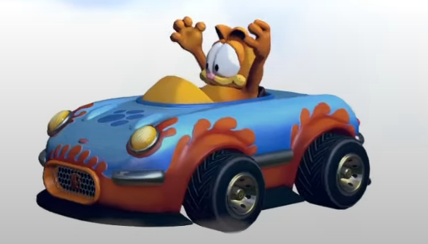After vaporizing the fake food, gardefield then decided to take part in one of his favorite pastime activities. He walked at a moderate pace to make his way to his ScreenON Game PC Extreme Edition – Ryzen 9 7950 – 16TB NVMe SSD – 256 GB RAM – RTX 4090 computer. This computer was crafted specifically for the hit videogame Garfield Kart – Furious Racing, a game in which Garfoiled himself took place. He needs 60 fps after all. After arriving at said computer and starting the game though, he suddenly received a call on the hit communication platform ‘Discord’, causing a mild disturbance in his plan.  
‘This is quite the unfortunate occurrence’, said the field. He decided to ignore the call at first, and picked himself in the videogame, using his signature car, “carfield”, along with it.

However, while he was busy cooking the NPCs, the right side of the screen suddenly filled up with message spam, causing garfeidols vision to become rather limiting. This was initially no problem for him since he is such an epic gamer, but eventually it did become a slight hinderance. He was not happy with the fact that the right side of based garfeild was covered up with cringe messages. So, after emerging victorious in the race and lapping all the NPCs, he decided to take action in order to get rid of the disturbing force. Nothing may stop the field from garfing after all. He quickly opened the hit app ‘Discord’ and decided to check out which individual was daring to step into his garfing business. However, much to his surprise, there were no messages. He inspected who could have spammed him, but there were no traces left. Only a few DMs from people that he was too lazy to respond to, and those were already a few years old. There was not much time to inspect for much longer however, because the clumsy rizzler Jon Arbuckle was quick to disturb garfoileds inspection. He stumbled into the room, approaching garfieodl the cat.

‘Garfield from the hit movie Garfield Gets Real.’ said the Jon.  
‘I’m going to get ingredients for lasagen. You better not perform mischievous activities in the household while I’m gone, you silly wide individual. Do not kick Odie into orbit and do not throw Nermal into the trashcan. Speaking of Nermal, I have not witnessed his presence in some time, I wonder where he could be. If I figure out that it was you who lost him, there will be big consequences! Anyway, Jon out, I’m buckling my Ar.’  
Jon Arbuckle then left the room, leaving Garfeidl alone with his computer and his deep thoughts. Jon’s words came and went, his mind too filled with thoughts about the earlier spam during his garfing session, unable to think and listen rationally. He decided to once again try and inspect this matter, but there were still no signs of special messages. This alone made the field relatively uncomfortable. He decided to garf his kart for a little longer, but the thoughts remained inside of his head.

# 2. how garfield became handsome

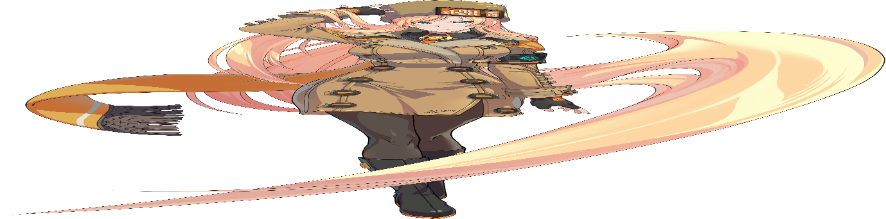Garf went on and on, karting for another hour straight, going online as the fans of his epic gaming pc spun silently in the background. He was totally gaming on his online opponents, making every unqualified garfer shake in their boots, and making them leave after the first race. Eventually though, after a few more minutes, he could sense an audible noise from behind him. But it wasn’t the computer, nor was it Jon Garbuckle. Field knew this because Jawn left the establishment a while ago in order to get lasagen ingredients. He peeked behind him, interrupting his garfing session once again, much to his inner despair. But he saw nothing. Only the ordinary solid objects that were always inside of the room. He just had to investigate further though, as gar felid would not let this minor mishap slide. He fell out of his lazyboy x garfield movie garfiedl gaming chair, and stumbled towards the exit of the room, seeing if there was any individual other than Jon present inside of the house. He managed to open the door, and checked out the hallway to see what was up, but no one showed up. He stood and looked around for a little longer, but he could feel his legs trembling. His sixth sense was obviously experiencing a lack of Garfield Kart dopamine. When a minute passed, he decided to close the door, and continue his garfing by stumbling back into the general direction of his computer’s location. However, Garfoiled got jumpscared hard when he realized something. There was a certain entity in the left corner of the room. He quickly turned around, immediately using his garfing senses to detect that there was something horribly wrong.  
‘*Zdravstvuite (Здравствуйт), Garfield.*’  
The identity revealed itself in garfoiedls full vision. When the orange feline looked up, he saw a tall figure. At least, compared to his 3-foot self. A woman with a short trench coat, orange shawl and a Russian fur hat was standing there, leaning against the wall as she looked him right in the eyes. Her blonde shining hair was very long and admirable, it sways rhythmically with her breathing.  
‘Damn, white, blonde female specimen jumpscare’, said the field right in front of the lady.

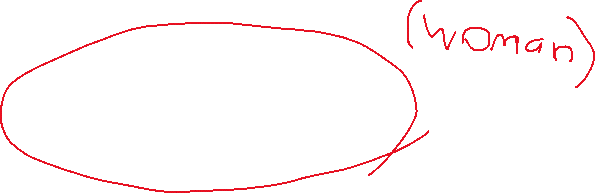

Glarmfield looked relatively careless about the sudden appearance of this female human specimen inside of his home, but from the inside he was rather terrified, wondering how this creature entered the establishment in the first place.  
‘Hmm, you are on the… “large” size, aren’t you?”, the woman said.  
‘You must be Garfield. My name is Millia Rage. It’s quite an exquisite experience to be meeting you in person, Garfield.’  
The garphelt looked at the female specimen, listening to her words as he was weirded out by the fact that she knew his name, but more so because she was literally in his house. Upon hearing her name though, his eyes widened, as he came to a sudden realization. He suddenly cleared his throat, and started speaking as he looked Millia into her eyes, raising his finger to ask for silence.  
‘Millia is too hot like, whenever I fight one I just have to throw the match, I need to see her victory animation and it tu-’  
Garfoiled was then cut off by her, being slapped with her hair forcefully.  
‘Don’t even start.’  
She looked at the orange feline, her cold look being ever so apparent. She looked quite serious.

‘My sincere apologies, Mild-leeya. It’s just that your name reminded me of this exquisitely humorous paragraph.’, gearfield said with a serious tone, but it partially and unintentionally came off as mocking the woman’s serious and cold attitude. Millia sighed audibly, her eyes closing for a moment as she came back to her senses.  
‘Listen, Garfield. There is a reason as to why I’m currently here. Please do not be frightened by my presence. I apologize if my introduction was rather sudden and unexpected.’  
Garfeteld’s smirk was quickly wiped off his face, noticing that the woman read his inner feelings, and that she looked straight through his silly attitude. She didn’t even complain further about what he said earlier. He sighed and shook his head.  
‘Yes, do explain why you are suddenly real, and why you are in my epic establishment, por favor.’, he said with a quieter tone behind his words. Millia stayed silent for a moment, looking out of the window as she listened to garrfeiold’s computer fans whirring silently. She sighed again.  
‘Hm, just to confirm, Garfield… you are a big fan of… the Italian meal “lasagna”, correct?’, she said as she pulled out a sticky note with an image of lasagna on it. Garfild’s eyes became widened, a neuron activation taking place, and he immediately jumped towards the sticky note, grabbing it and eating it up immediately. After a few seconds, he made a weird face expression, realizing that he consumed paper instead of tasty lasagen. Millia smiled.

‘That confirms it quite well, I must say. You are the one that I’m looking for, Garfield’, she said as she looked at him, while he was busy processing what he just did. Her cold look was gone for a little bit as she enjoyed the sight of the goofy feline doing his thing.  
Grafield took a little longer to get rid of the unpleasant taste of paper in his mouth, before finally turning his attention to the woman again. When she noticed that garfs attention was pointed towards her, she started speaking once again.  
‘Anyways, ever since you opened that door to check on the noise I made, I already sneaked by. I figured that your reaction time is quite… hmm… how do I say this… leisure. But like I said, please do not be alarmed.’  
Garefelt made a neutral expression. He knew that his reaction time was only good while playing the video game Garfield Kart – Furious Racing, and so he had no obvious opportunity to ratio the woman, much to his disappointment. And so, he switched the topic, whilst also trying to get straight to the point.  
‘Millia the rage, what is the real reason for your presence? Why did you interrupt my garfing session? And why did you not just call me?’, garfeoidl said with a slightly intimidating tone, or at least, he tried to come over that way. Millia’s cold and emotionless expression began to return a little.  
‘I did’, she said while gazing off at garflelts computer. She noticed the title screen of the game he was playing; she tilted her head slightly.  
‘However, I didn’t receive an answer, nor did you seem to respond to my messages. Since this is quite an… urgent matter, I figured that I would have to contact you in person. Hence why I’m here right now’, she said whilst stroking a lock of her hair, and looking at him.  
Garfeilio didn’t seem to buy any of this at first, but then realization struck. He remembered the moderately high number of messages that appeared on his screen earlier, but he never got the chance to read their contents, or the sender’s name for that matter, since he was too busy garfing his kart. The woman seemed to notice his reaction, and she nodded.  
‘Okay okay, what do you want?’, garfoidl said, knowing that he was better off listening to her, rather than trying to shoo her away for more Garfield Kart. When he asked this, her expression seemed to harden more, as she stared out of the window with a hateful expression. Then she sighed, turning back to the orange cat, as her expression softened just a bit to not upset him.  
‘I’m assuming you have heard of a gray-haired individual named Nermal?’  
She said this with a rather mysterious and somewhat sorrow undertone.  
As expected, Gariefodld immediately started fuming at the sound of 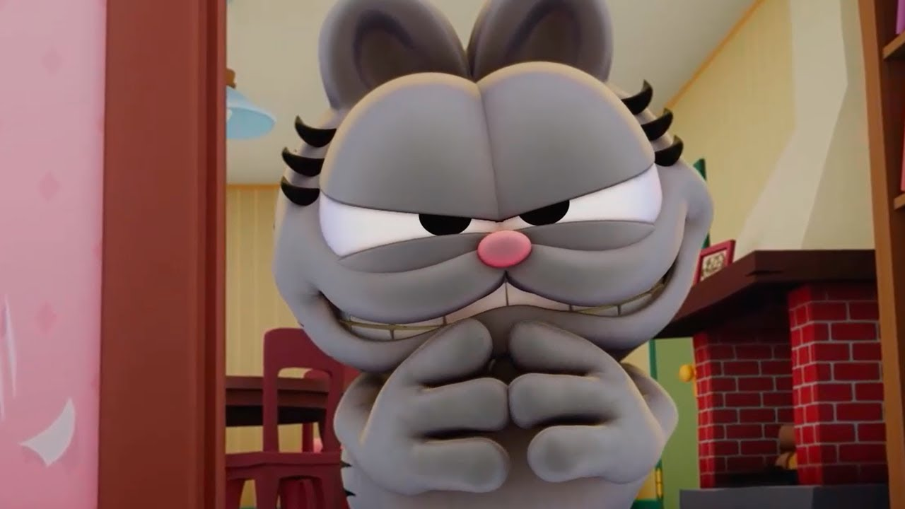Nermal’s name.

Millia saw this, and in response, she picked the fat cat up with her hair and held him in front of his computer screen, which was still running the hit videogame Garfield Kart – Furious Racing. The energy from the title screen nullified garfieodlds anger.  
‘You really need to control your rage, you know. I’m not going to be able to do this every single time Nermal is mentioned’, she said with a calm tone.  
Gaorafield could think rationally again, and his eyes sparkled, as he heard something.  
‘Omd, control my rage? Is that a Millia Rage reference?’  
He got 6P’ed by her and was put down on the floor again.  
‘Focus.’ She said it with a stern voice, realizing that she made the mistake of saying her own last name. She facepalmed and sighed, looking over at the fat orange feline creature again. She spoke up with a slightly less stern tone, but still relatively dominant sounding.  
‘This is a serious matter. You can NOT be making jokes right now. Save them for later, if you will.’  
Grafetld rubbed his eyes, then spoke.  
‘Fine, continue. What’s with Nermmammal?’, he said upon recovering from the knockback. He was still relatively angered by the sound waves entering his ears, not pleased by hearing the word ‘Nermal’, but he kept his cool this time. Millia’s face suddenly got a little pale, as she looked at the wall for a few seconds. She then sighed audibly once again.  
‘He’s… well… he’s…’ She was tripping on her own words.  
‘We can get to the specifics later… the point is… if there’s a time where we need you, it’s now.’  
Garmefiesld did a The Rock reference, except he did not have eyebrows. However, despite this facial expression, from the inside he was getting a little fearful of what was being said to him.  
‘Define “we”, won’t you’, he said.